Mark Malloch-Brown is a former UN Deputy Secretary-General and head of the UN Development Programme. He’s a UK citizen and has served in the UK Government. As SG, he would bring a broad understanding of the UN family and ideas for how to effect change in the institution. Broadly respected by peers, he would draw the support of many reformers around the world.

<http://upload.wikimedia.org/wikipedia/commons/5/5a/Lord_Malloch_Brown_2.jpg>

https://twitter.com/malloch_brown

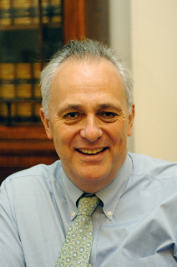

Tags = development, humanitarian assistance, governance